Digime

P. Křížkovského high school with artistic profiling Ltd.
Methodology Research on the influence of microclimate – a long-term student field experiment

Contents:

Methodology Research on the influence of microclimate – a long-term student field experiment 3
Objectives: 3
Didactic methods used: 3
Format: 4
Annotation: 4
Financial calculation of the complexity of the project: 5
Time schedule: 6
Work team: 6
Progress of the project implementation phase 7
Choosing a project topic 7
Creating a team 8
Brainstorming 8
Activity Preparation of the experimental plot 10
Automatic watering activity 21
Activity Measuring the CO² level around plants 22
Temperature and humidity measurement activity 28
Conclusion, output of the project. 30

Methodology Research on the influence of microclimate – a long-term student field experiment

Objectives:
competences – the implementation of this project complements and develops multidisciplinary knowledge and understanding of natural phenomena, expands and develops a wide range of key competences for pupils and teachers: competences for learning, problem solving, communicative, social and personal, civic and work.

Didactic methods used:
The long-term student experiment is naturally a heuristic cognitive method, the main advantages of which from a didactic point of view include student interest, systematic work, learning by experimenting, and problem solving. The long-term pupil experiment is very suitable for the use of modern pedagogical methods, allowing high motivation of pupils and the development of a sense of self-confidence of pupils, healthy socialisation (a small work team allows pupils to feel safe, which allows obstacles to become challenges for pupils). A sense of autonomy (students organise their actions and develop in such a way that they are able to accept the positive and negative consequences of their actions). Inner motivation. The methodology is based on 5 areas:
- Group management
- Building interpersonal relationships
- Building a social climate
- Individualised learning process
- Relations between school and family life of pupils

Link to external document http://www.golden5.org/golden5/?q=en/node/21

Format:

The entire project is a long-term student experiment, which will gradually lead the students through logically connected (connected) activities that will teach the students to plan, evaluate and solve problems occurring during the experiment. However, the selected activities of the project can be implemented (after simplifying the implementation and expected outputs, according to the level of the student teams) as separate learning activities - e.g. measurement of the content of carbon dioxide, oxygen in the air and their changes due to the activity of plants and soil organisms, temperature measurement and the connection with the weather . Simplified search and experimental verification of the connection between surface types and microclimate, automatic irrigation system….

Annotation:

The long-term student experiment – Research on the influence of microclimate enables the inclusion of a current and important topic – cheese in microclimate and methods of adaptation to climate change – in the teaching in accordance with RVP – man and nature. The project connects the development of theoretical knowledge – climate, water cycle, photosynthesis, plant physiology, modern green architecture. The project is designed in such a way that it highly activates the participating pupils, deepens their ability to work together, propose solutions to problems and verify solutions experimentally. Pupils independently use modern measurement methods, evaluate measured data, and propose suitable methods of their visualisation. The result of the project is a logical presentation of the obtained results by the student team.

Financial calculation of the complexity of the project:
If you have some equipment available – garden tools, micro:bit, data coverage, pc, ntb, or Pasco/Vernier measuring system, the costs of the project are only in the details, additional purchase of sensors, construction of the irrigation system. After the completion of the project, the micro:bit measuring systems can be used for regular natural science teaching.
This long-term experiment is made up of individual activities that can be implemented, even independently – this significantly changes the financial complexity of the project. We recommend that schools choose activities according to time and financial possibilities.
ElecFreaks BBC micro:bit kit for a smart home Kit variant: with micro:bit V2 board - https://www.hwkitchen.cz/bbc-microbit-kit-pro-chytrou-domacnost/?variantId=6188 – approx. 2 000 CZK
Pasco scientific contact thermometer - https://pasco.cz/senzory-a-cidla?tag=1-fyzika approx. 4 000 CZK
Pasco scientific non-contact thermometer - https://pasco.cz/senzory-a-cidla?tag=1-fyzika approx. 5000 CZK
Pasco scientific datalogger 25 000 CZK - https://pasco.cz/senzory-a-cidla/9-rozhrani/116-datalogger-spark-lxi 25 000 CZK (not necessary, can be replaced by installing Pasco sparkvue 5 500 CZK - https://pasco.cz/senzory-a-cidla/10-software/78-sparkvue-jednopocitacova-licence )
Solar panel 1 500 CZK (not necessary – sensors and irrigation system can be powered/recharged in the classic way) - https://www.mironet.cz/viking-vsp30w-cerna-solarni-panel-30w-ipx5+dp510718/
Weather station 8 000 CZK (not necessary – can be replaced with data from the meteorological service or station) - https://www.meteostanice.com/Wi-Fi-meteostanice-GARNI-2055-Arcus-d1646.htm

Time schedule:
The realisation of a complete long-term experiment requires a time period of several seasons. Preparatory work – team building, brainstorming, theoretical preparation, basics of working with micro:bit, measurements using measuring sets (Pasco), installation of a local weather station – should be carried out before the beginning of the growing season - i.e. January-April. Field work – preparation of the experimental plot/area, planting + surface treatment, determination of soil sorption properties, installation of the irrigation system, individual parameter measurements, evaluation of the measurements must be carried out in a climatically temperature and hydrologically demanding period – optimally at the beginning of summer/autumn. We have prepared the individual activities so that their time requirement corresponds to a classic lesson - 45 minutes. For the successful management of each activity, we recommend a short preparatory team meeting – explanation of the activity, division of individual tasks, work organisation and team motivation. We successfully used online meetings in the MS Teams environment for the preparatory phase of the activities (any similar application can of course be used). Individual meetings and activities of the student/teacher team should be held regularly without major time interruptions – in accordance with the Golden5 methodology used, we thereby deepen cooperation, trust and a friendly working atmosphere in the team. Possible longer gaps – vacations, illnesses, epidemiological measures – should be filled with short, undemanding activities – photos of the team's activities, examples of microclimate measures implemented on Earth, in the city, views of the course of the weather.

Work team:
Our experience shows that this type of project makes it possible to create and develop the activities of a small group of 5-10 students and teachers. It is advisable to enrich the team structure with students of different age/knowledge levels. We also recommend creating gender and socially rich/inclusive teams. Individual activities alternate the type of work-predominant cognitive activities so that all key competencies are developed, taking into account individual personalities.

Progress of the project implementation phase

Choosing a project topic
Currently, long-term climate change is one of humanity's most serious problems. The changes are global and of course also affect the region of the Czech Republic.
In the long term, temperature changes and the distribution of precipitation during the year are documented. These changes have clear and fundamental impacts on our landscape, they affect all the communities of our ecosystems and, last but not least, they affect us as humans.
We can observe the impacts in the landscape, afforestation, in agriculture, in changes in sources of drinking water, in more frequent extreme weather fluctuations and also in the environment in cities.
Our school, the P. Křížkovského Gymnasium, is located in Brno, the largest city in the South Moravian region of the Czech Republic. In recent years, the temperature has regularly risen above 30 degrees Celsius for several weeks in the summer. These days, however, it can be observed that the highest temperature is usually measured in the city centre, in areas that are completely built up with houses or covered by roads, parking lots and other buildings. Unlike the outskirts of the city, which are rich in greenery or the larger parks in the city, where the temperature during the day is also high, but always lower than in completely built-up areas. During the night, the differences are even more noticeable. Built-up areas of the city radiate heat even at night, while places rich in greenery cool down pleasantly at night.
This led us to think about the topic of our project. How, with the help of IT, in a creative way, pupils explore and propose procedures and solutions for improving the climate in cities.

Creating a team
We have created a creative team for our Digime project. Two teachers became its members, guarantors of the project: Mgr. Jindřich Zdražil, teacher of chemistry, physics and ICT and Mgr. Ivana Galíková, biology and mathematics teacher. We invited creative, science-oriented fourth grade students to the team – Barbora, Ema, Julia, Markéta, Václav and Jan. As the Covid-19 pandemic affected the entire world, the project schedule was changed and extended for another year. In the meantime, part of the students left to study at other schools, so our team was supplemented in 2020, and a team composed of: Jindřich Zdražil, Ivana Galíková, Barbora, Ema, Václav, Dorota, Adam and Lucie worked on its completion.
This year, students attend fourth and fifth grades, they can work independently, think and solve problems. They approach project challenges in a creative way, record procedures, present hypotheses and verify them with the help of IT technologies.

Brainstorming
One of the most important phases of the project is brainstorming. Team members need to be properly motivated and create a work strategy together. It is great to let children create it, because they have a lot of original ideas, they are not bound by almost any restrictions, both in imagination and in the practical part.
When choosing a team, it is necessary to emphasise the independence and creative vigour of the children. It is necessary to invite to the team children with an interest in natural sciences, computer technology, children that are able to work independently, but also able to work with their colleagues in the team. Working in a team strengthens communication competence, responsibility, and creativity. Long-term work in a team leads children to a responsible approach to a joint task, which is highly desirable for their future professional activities.
The team leaders – i.e. the teachers – gave the children the opportunity to choose a topic for the project. A topic that would be related to the global problem of climate change and the use of IT technologies.
Among the many proposed topics, the team jointly chose Research on the influence of the microclimate. Personal experience with temperature changes in the city of Brno and the lack of precipitation, especially in the summer, played a role.
Based on theoretical knowledge, our creative team decided to practically test their hypotheses, which would relate to the proposed measures to improve the microclimate.
The basic milestones were the following problems:
Bad management of rainwater in cities instead of its use, minimal retention of rainwater in built-up parts of the city
Significant overheating of built-up parts of the city in the summer months and the subsequent necessity of cooling buildings, high energy and financial demands of these processes
The theoretical part of solving the problem involved the study of green roofs in cities. Pupils got acquainted with various technologies, their benefits and risks, as well as technical and financial solutions to the problem. They studied the possibilities in the city of Brno, which provides subsidies for green roofs. The goal was to find out under what conditions and with what subsidy a green roof can be purchased. The main benefit was the realisation that the installation of a green roof has several advantages:
Retention of rainwater
Insulation of the roof against excessive overheating, thus reducing the cost of cooling the building in the summer months
Insulation of the roof against heat loss in the winter months, thus reducing interior heating costs

The team agreed on the following workflow/activities:
1. Choose an experimental plot that will represent a typical place in the city with enough sunlight during the day
2. Monitor with the help of IT technology weather during the year at the property
3. Choose different types of surfaces on the experimental plot and divide it into sub-trial plots
4. To measure with the help of IT the surface temperature and the temperature at a constant depth under various surfaces
5. Measure the sorption properties of the soil and monitor changes in humidity under individual surfaces
6. Surfaces are made up of non-living materials and plant cover. To maintain sufficient moisture for the experimental plant field, the field is automatically irrigated using IT
7. After continuous data collection, evaluation of the results, comparison with established hypotheses and statement of the conclusion

Activity
Preparation of the experimental plot
Target:
Acquisition of work competences, theoretical and practical preparation of the trial plot
Motivation:
The most important are own experiences and the most valuable reward for work is a tangible result
Activity duration:
Approx. 5 hours for the whole team
Gadgets:
Garden tools – spade, rake, gardening shovels, drip irrigation, boundaries of trial plots, various materials for covering the surface of the soil
Previous preparation:
Choosing a suitable place with optimal exposure time, choosing and purchasing the necessary equipment

For their project, the team chose an experimental area on school grounds. As it was a densely overgrown field, it was necessary to clear the land first
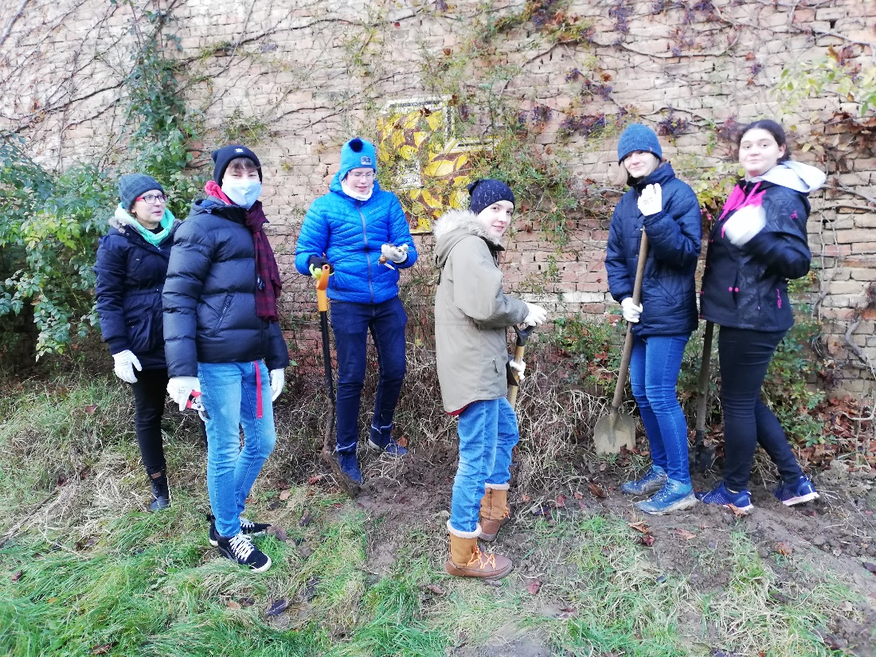
Pic. 1 - The team is working to clear the trial plot
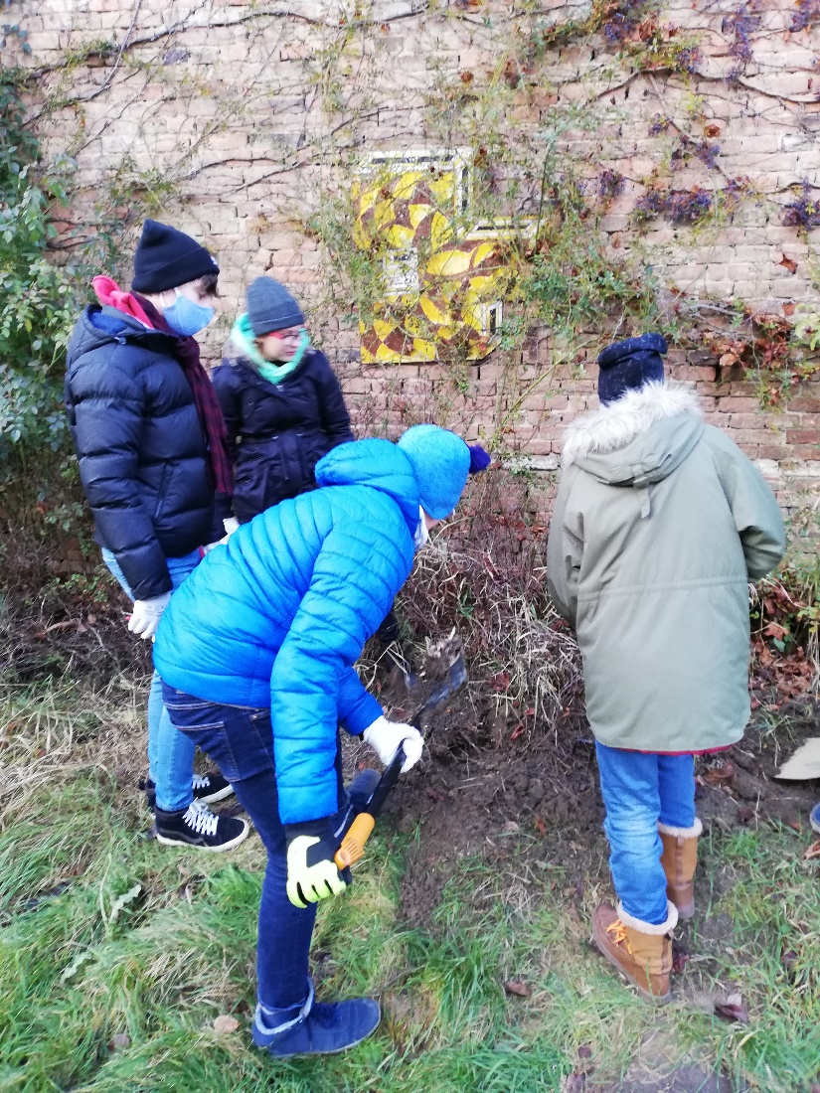
Pic. 2 – The land must be dug up, cleared of plant cover, roots and plant remains must be removed, and the substrate ground and homogenised
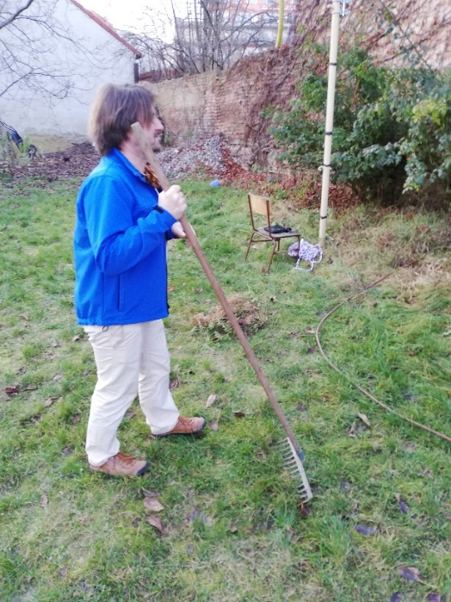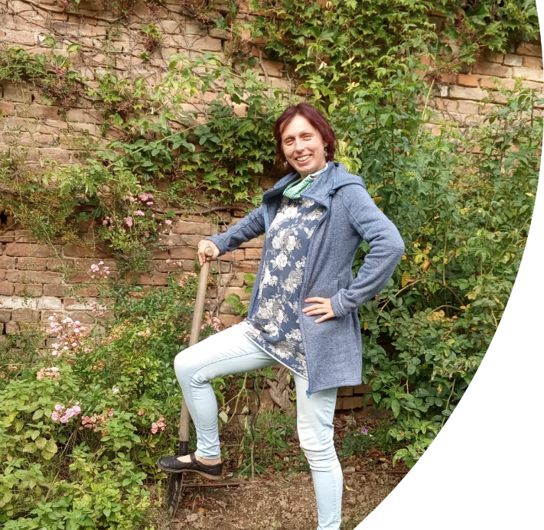
Pic. 3 and 4 - Some work tasks require learning by motor association and learning by imitation

For the experiment, the team marked out an area of ​​400 cm x 120 cm. The entire area had to be dug up and cleared of plant cover, including the root part. The soil was evenly loosened, processed and modified

The team divided the experimental area into 10 trial plots, which were covered with different materials, sown and planted. The team members selected the following materials for the cover:
1. Moss
2. Paper cartons
3. Sand
4. Fine stone chips
5. Coarse stone chips
6. White stone chips
7. Wood chips
8. Bare ground
9. Seed – spinach
10. Planting – watermelon
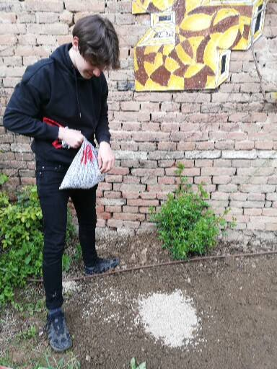
Pic. 5 - Covering experimental fields - white stone chips
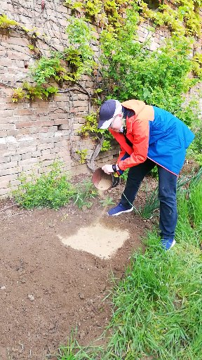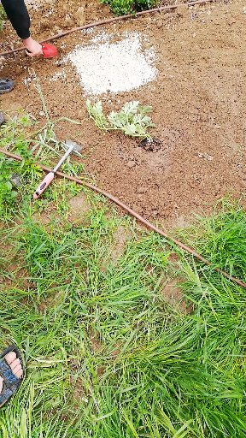
Pic. 6 and 7 - Covering experimental fields – sand, crushed stone
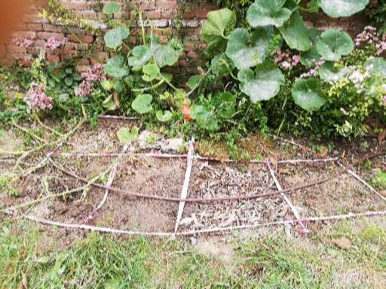
Pic. 8 - Subdivision of the experimental field into individual fields, installation of drip irrigation
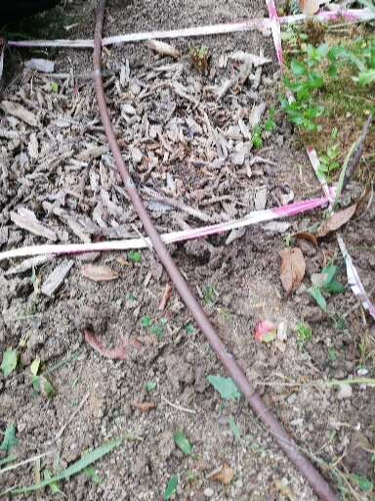
Pic. 9 – Cover – wood chips, irrigation installation
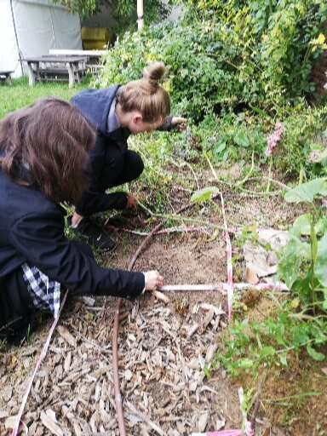
Pic. 10 - Ongoing care of the experimental
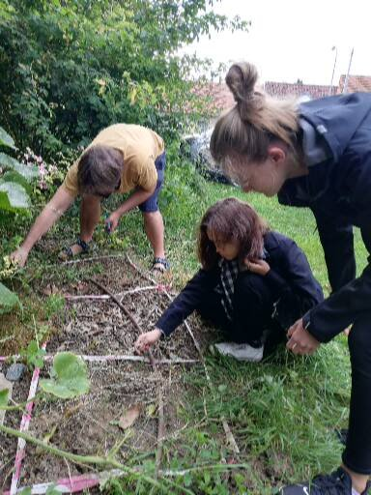
Pic. 11 - Sowing cover plants – spinach, radishes field - cleaning from weeds
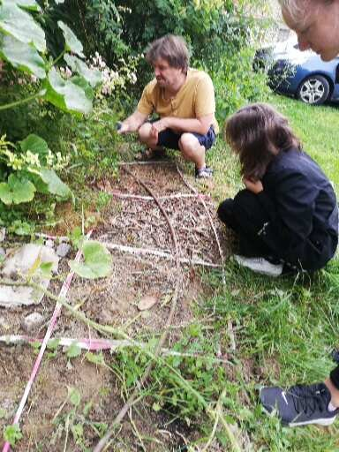
Pic. 12 - General view of the experimental field
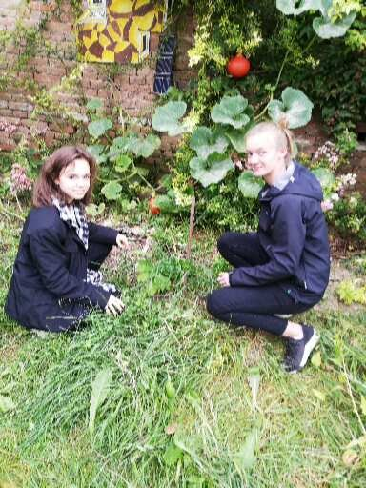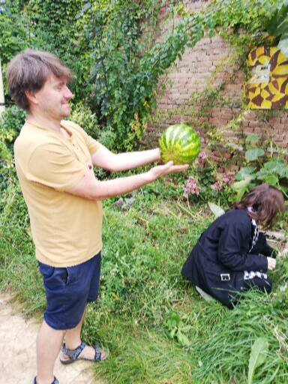
Pic. 13 and 14 - Planting a commercial crop – watermelon in May and harvesting it in September

Automatic watering activity
Target:
Students will acquire the ability to design, practically construct and improve the execution – innovate their solution to the problem – of an automatic irrigation system.
Motivation:
Show students the course of temperatures and precipitation in a dry year – we used data for Brno 2020 - irrigation needs to be solved economically and automatically with the use of IOT. For motivation, we searched and discussed the solutions used in the arid regions of the planet – Israel
Activity duration:
Depending on the focus of the project, students can be asked to solve all or only part of the sub-tasks. Design of the initial solution (inspiration from finished IoT projects – we used the micro:bit Smart Home solution) 2h + construction 4h + programming of the microbit controller 2h + verification of the functionality of the entire solution 2h + repairs and improvements to the design - in total the project took us approx. 6h – the most frequent failures occurred pump switching - we recommend using micro-irrigation in a drier environment. For example, only in the classroom.
Gadgets:
Micro:bit Smart Home, or other self-watering system
Description:
The expansion kit for the micro:bit Smart Home contains a ready-made and tested solution that is a good basis for the construction and programming of the irrigation system. We recommend that the students examine the set, reveal the function of the individual components, and let the students propose independently how to assemble a functional solution from the given components - then compare the student ideas with a sample solution from the set manufacturer. Then discuss the differences in the solution – our team suggested deepening the water tank into the ground to increase stability and reduce water evaporation. We recommend solving the problem of clogging the pump with the students at the beginning – the multiplication of algae and the ingress of dirt into the tank are inevitable during prolonged use. According to the focus of your project and adjust the students' activities – the students can program the system and solve the mechanical parts of the irrigation system. Or, on the contrary, extend the experiment by measuring water consumption, adding nutrients. The importance of an irrigation system in outdoor conditions can significantly reduce above-average rainfall – as happened to us (students then easily get a sense of the insignificance of modern irrigation systems - classroom use may be more appropriate from this point of view.

Activity Measuring the CO² level around plants
Objective: Students will acquire the ability to design a method for measuring the concentration of carbon dioxide. Students will acquire the ability to look for method problems and seek their solutions.
Motivation: living organisms breathe and release carbon dioxide as a waste gas, therefore monitoring the content of O², CO² can be used to monitor the photosynthetic activity of the plant
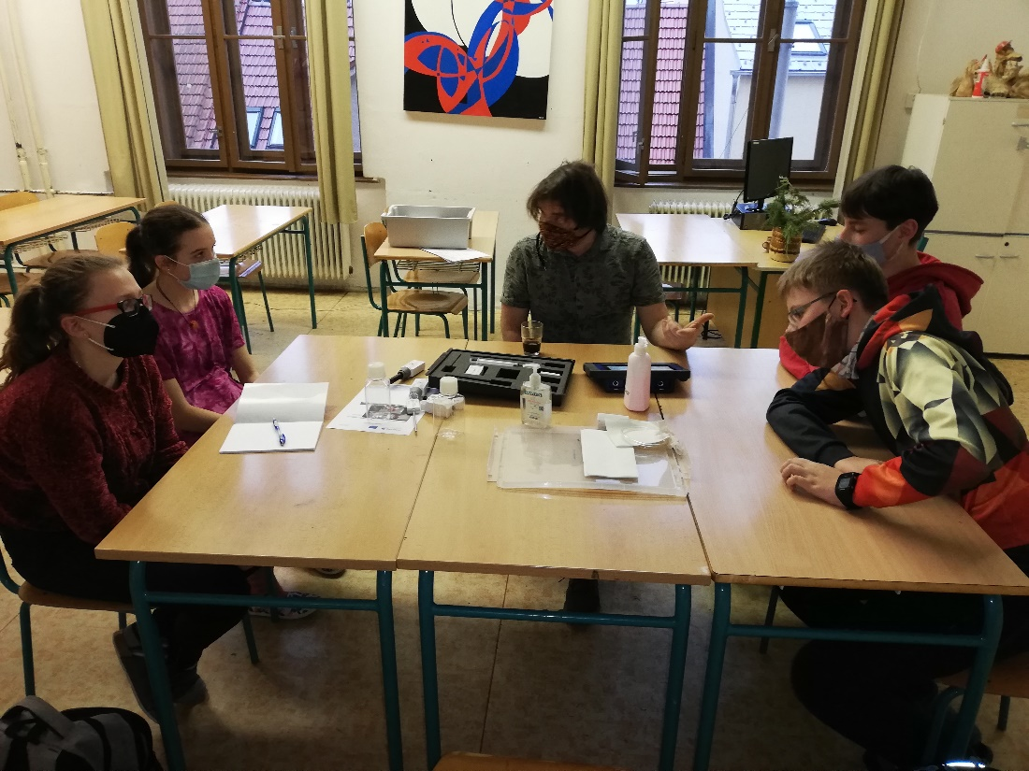
Pic. 15- CO² measurement methodology
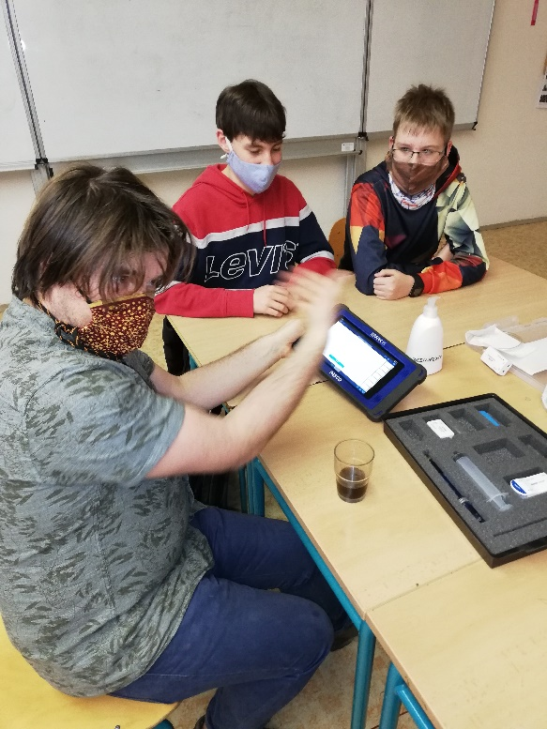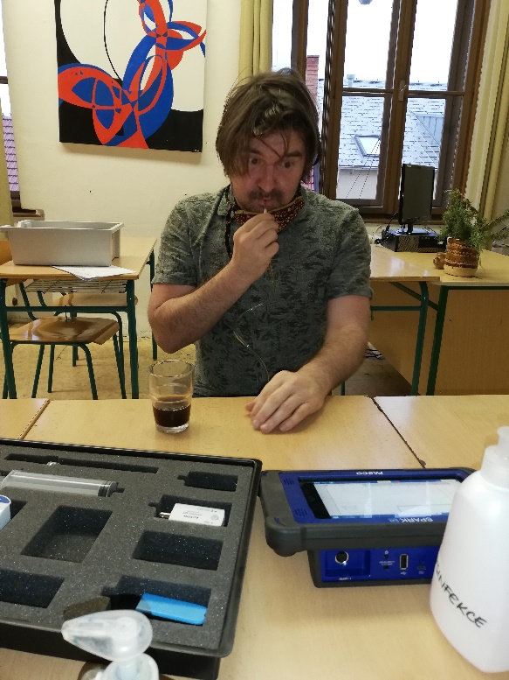
Pic. 16, 17 - CO² measurement practice
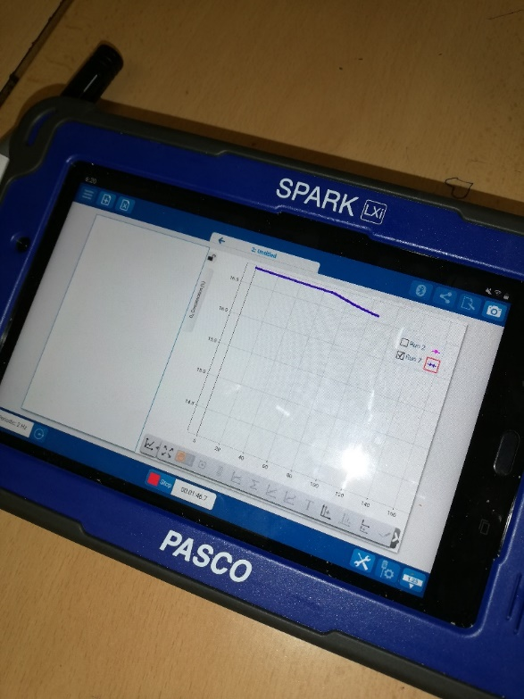
Pic. 18, 19 - CO² measurement practice
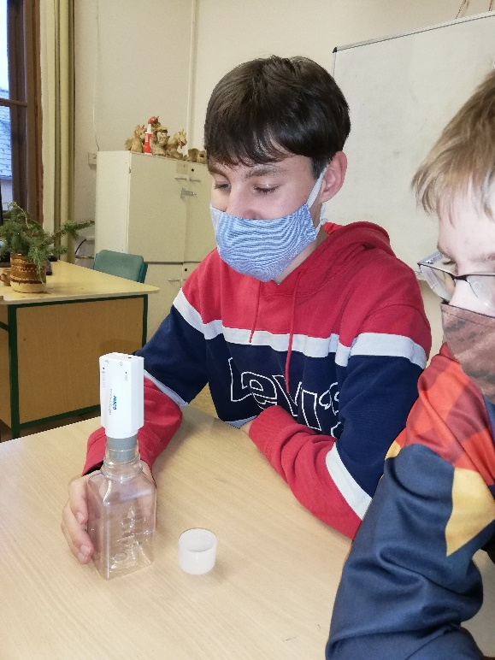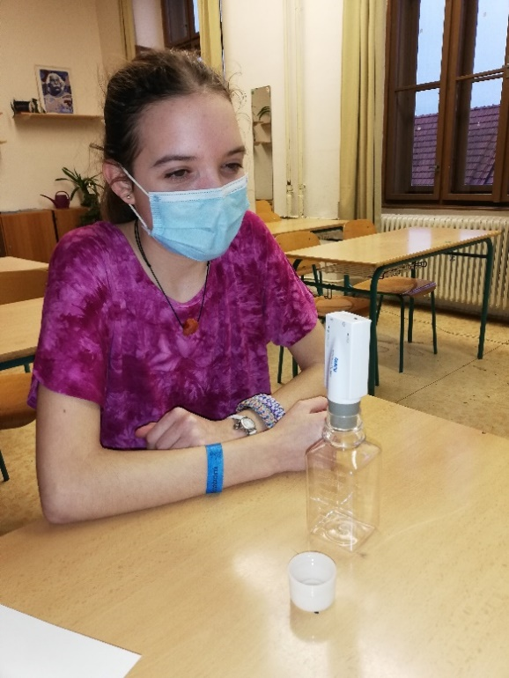
Pic. 20, 21 - CO² measurement practice

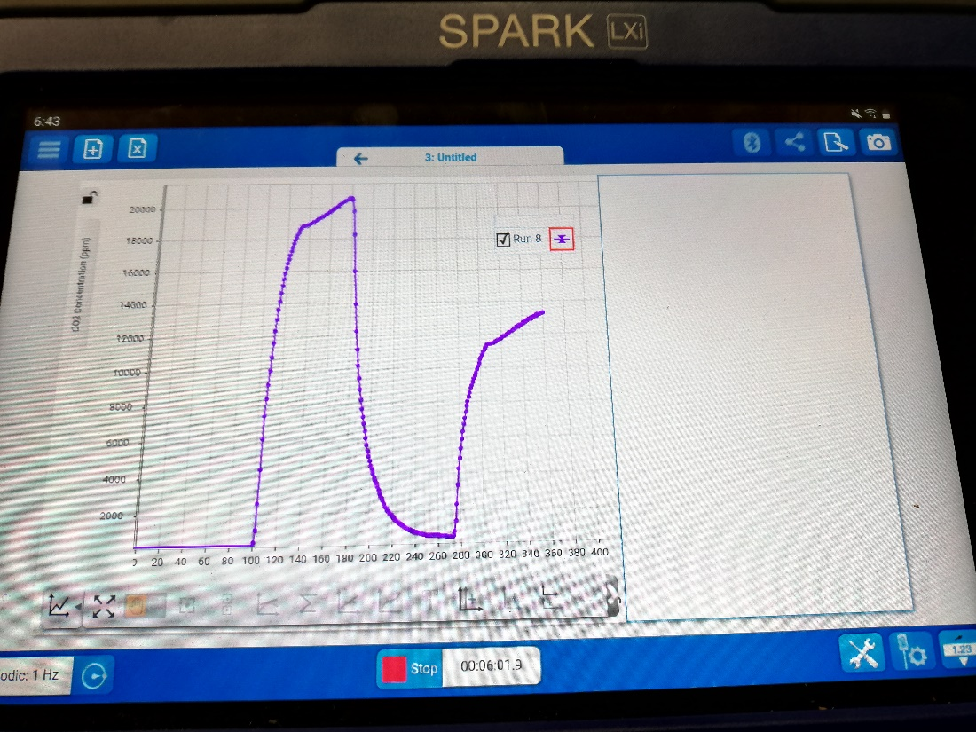
Pic. 22 - Measurement by the sensor of the Pasco kit – resulting graph
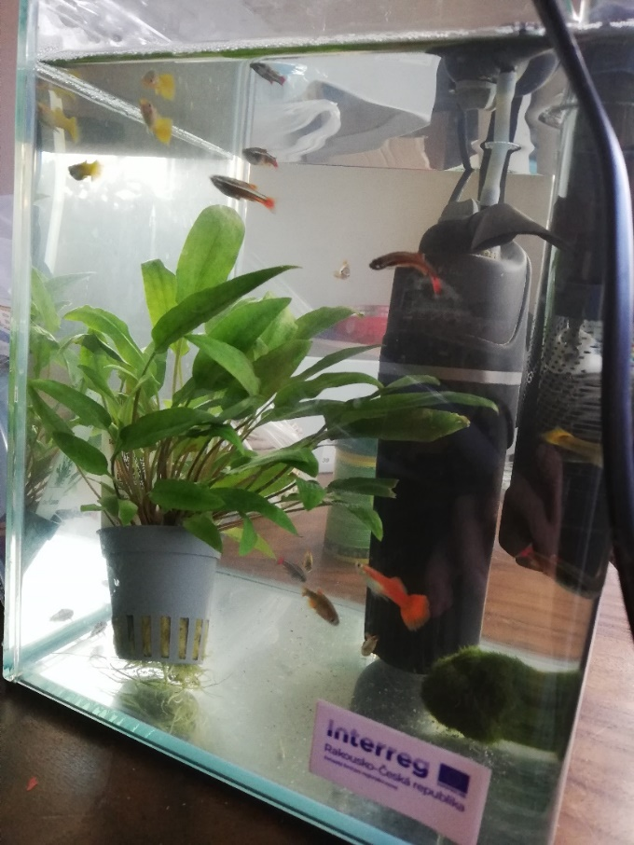
Pic. 23 - Monitoring CO² production by plants
Activity duration:
2h (with assembled micro:bit CO² measurement set)
Gadgets:
Measuring set Pasco or micro:bit CO² measurement, or other measuring system
Previous preparation:
According to the level of knowledge of the students and the focus of the activity (more advanced micro:bit coding, or measurement of plant respiratory activity), we have prepared complete micro:bit kits with a carbon dioxide level sensor. If you plan to use the activity to improve students' programming of the micro:bit (connecting the micro:bit to wifi and sending data to a cloud file server), have the students program and animate the micro:bit CO² module

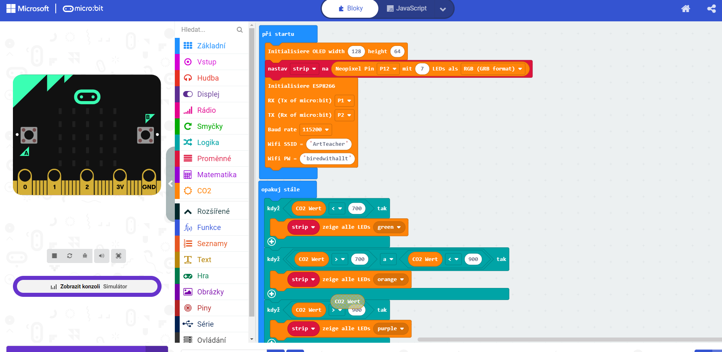
Our resulting monitoring and logging code is:
https://makecode.microbit.org/_CzpMXwf13Y1x

Description of the activity:
Monitoring the photosynthesis of planted plants by measuring the concentration of carbon dioxide during the day and comparing it with a control area without vegetation encountered difficulties in isolating the gases around the plants from the ambient air. The students came up with and tried several solutions – covering the plants with a transparent microtene bag – as insulation for gases did not work – the students discovered that the bag could not be hermetically sealed around the plant – in addition, there was a significant rise in temperature around the plant – danger of death. The second solution – covering the plant with an aquarium – during the day the concentration of carbon dioxide really increased, but similarly in the control plot – the students independently discovered the correlation of the concentration of CO² and the temperature under the aquarium while searching for an explanation of this mystery. They proposed and looked up a possible explanation on the internet – the release of carbon dioxide from the soil.
That's why we resorted to a substitute solution that has proven itself – to measure the photosynthetic activity of aquatic plants in the aquarium (it can be successfully replaced with a PET partially filled with water). Plants partially submerged in an aquarium or small container in adequate (we used direct sunlight) lighting and covered with a container (cut PET bottle) with a carbon dioxide-enriched atmosphere. In the atmosphere above the plant, we measure several times the concentration of carbon dioxide, possibly also oxygen according to available sensors. For implementation, we recommend inspiration https://experimentujeme.cz/images/experold/private/media/texty/786/fotosyntezakocovska.pdf
As a motivational part of the measurement, we recommend measuring CO²/O² with students in exhaled air, in gas over sparkling mineral water - etc.
When using micro:bit, it is advisable to store data in the cloud a suitable service is ThingSpeak. Instructions for creating an account.

Temperature and humidity measurement activity
Target:
Students will gain the ability to monitor the progress of their experiment, learn to measure the surface and subsurface temperature of the soil and determine the sorption properties of the soil
Motivation:
With the students, we went through sources about climate change, local records of temperatures in Brno. We talked to members of the local gardening community about their perceived changes in the microclimate of the city district. The data from the student measurements is used by the local public green management.
Activity duration:
Each measurement and its discussion for approx. 2 hours – the independence and self-confidence of the student team grew during the measurement – we still recommend the presence of a teacher – not as a "supervisor", but as a mentor, advisor in discussions
Gadgets:
Own meteorological station or current meteorological data from the school area – Pasco kit, contact and non-contact temperature sensor, soil sampling beakers, digital scale, calculator

Method:
We measure temperatures, if possible, on a sunny day so that there is a clear difference in the measured temperatures under different surfaces. Of course, we will also perform control measurements during the day without direct sunlight. It is advisable to measure moisture and the ability of the soil to retain moisture on a warm day after previous moistening (at least a day before)
Data evaluation
For temperatures, the result is clear immediately during the measurement. We let the students logically deduce in advance which type of surface will insulate best, then we confirm it with a measurement.
For humidity, we let the students derive the procedure - i.e. weighing the fresh sample, drying it (e.g. using a microwave oven), weighing the dried samples and calculating the percentage of water content
The students then easily deduced the procedure for measuring the sorption capacity of the soil. We recommend having students design and verify methods of increasing soil sorption capacity.
For data recording, we recommend either tables, graphs of the measuring system (data logger), such as Pasco sets, or a spreadsheet. Of course, you can also use a classic paper table.
We recommend always discussing the measured data with the students - putting them in the context of the meteorological conditions of the last days/day. Students gain an intuitive estimate of expected values ​​and the ability to detect a gross measurement error (here we point out the possibility of confusing temperature scales.

Conclusion, output of the project.

At the end, it is necessary to draw conclusions of a general nature from the acquired data/experience with the students:
• How did the type of surface affect the temperature and humidity of the soil?
• How much biomass did each plant provide?
• What parameters would be good to measure?
• Discuss their views on team work, their personal development.

The results of the project led to the intention to solve the unsatisfactory temperature in the school's mobile classroom – to equip it with a green roof, which will also be used for environmental education not only of our school's pupils, but also of the local community.
The weather records are used by the city's green maintenance department to predict the need for irrigation.
A suitable motivation for the practical part of the project is the choice of a vegetation that has a short vegetation period, grows quickly, and the team can monitor not only the growth of the plants, but also the harvest. Our team chose spinach, radishes and watermelon.
Spinach and radishes formed the plant cover from the end of March to May and the beginning of June, and watermelon from mid-May to September. The biggest attraction was the harvesting of the watermelon fruit, which weighed 3.20 kg and ripened optimally thanks to regular drip irrigation controlled by micro:bit.
This activity exceptionally supports work and communication skills. The activity was obviously new for the students, physically and logistically demanding, it was necessary to continuously keep the experimental plots with plants free of unwanted weeds, water them and monitor them regularly. Its conclusion with a successful harvest and tasting is a great positive feedback for the team members, an appreciation of their work and a confirmation of the correct cultivation methods.
It is necessary and appropriate to consult the students' parents about the project - we encountered active support of the students' activities even in their free time - the parents especially welcomed the development of independence and teamwork.
The students presented the project, its procedure and its results to classmates, parents and school management. We also used the presentation of ideas and solutions to assigned tasks at regular team meetings – we recommend it (healthy cooperation between students is clearly evident)
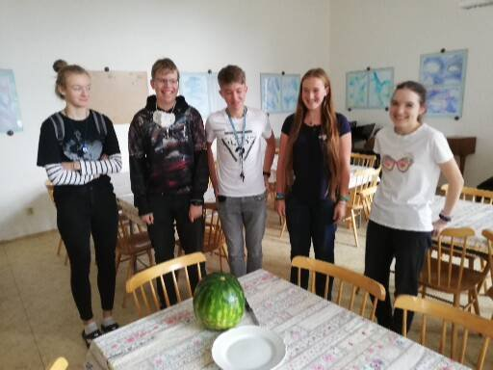
Pic. The team successfully harvested the watermelon fruit after 5 months of cultivation

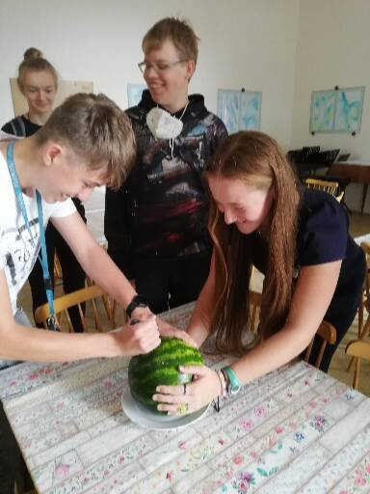
Pic. The team members selected responsible, manually skilled representatives and, with instructions on work safety, began to divide the fruit
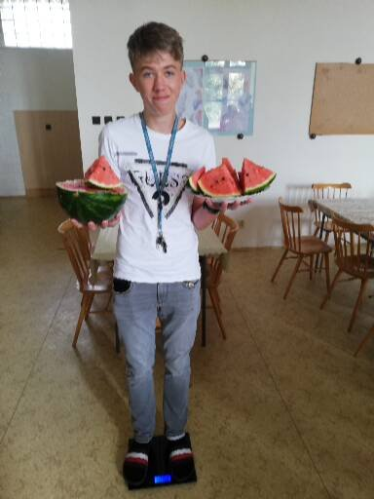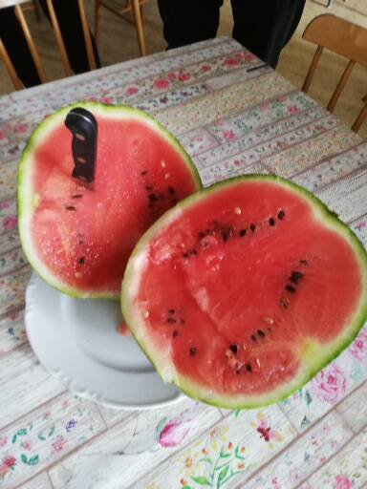
Pic. Adam weighed the watermelon - 3.20 kg Pic. Watermelon for the whole team

